

**Online Quiz….**

(A**n Online Test Application.**)

***(Application Screenshot’s)***

# Version History:

|  |  |  |
| --- | --- | --- |
| **1.** | **Author Name** | **DUDEKULA KALAM BASHA** |
| **2.** | **Purpose** | Screenshots of Application. |
| **3.** | **Date** | 09 April 2022 |
| **4.** | **Version** | 1.0 |
| **5.** | **Contact** | *Kalambasha9701@gmail.com* |

Contents.

**1. Project Outputs.** 3

# Project Outputs.

1) Home Page (Angular Quiz).

*Next Page:*

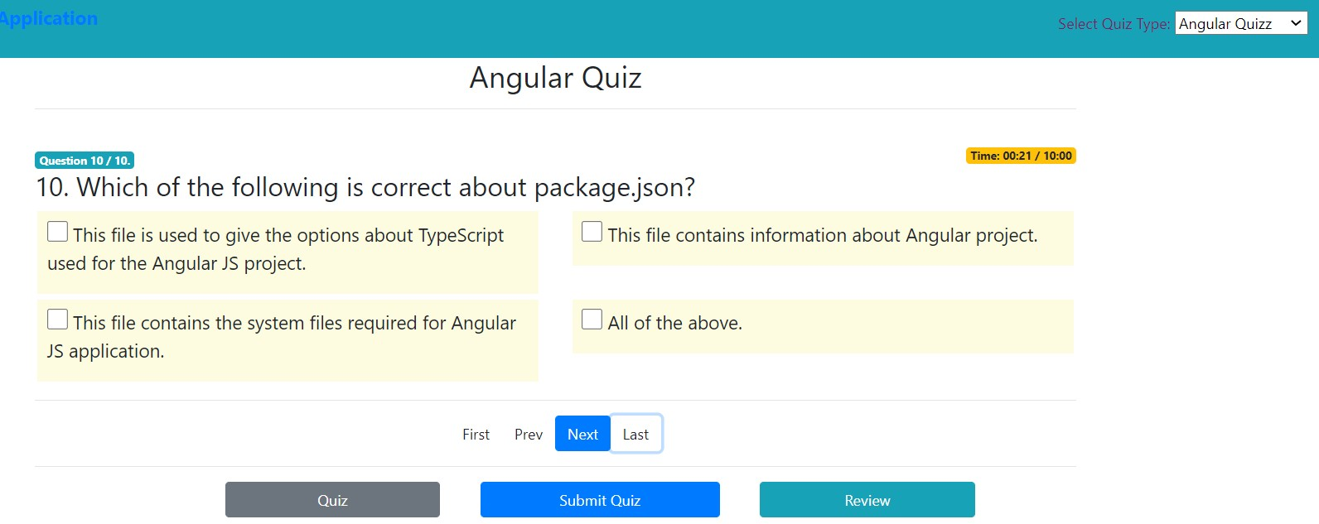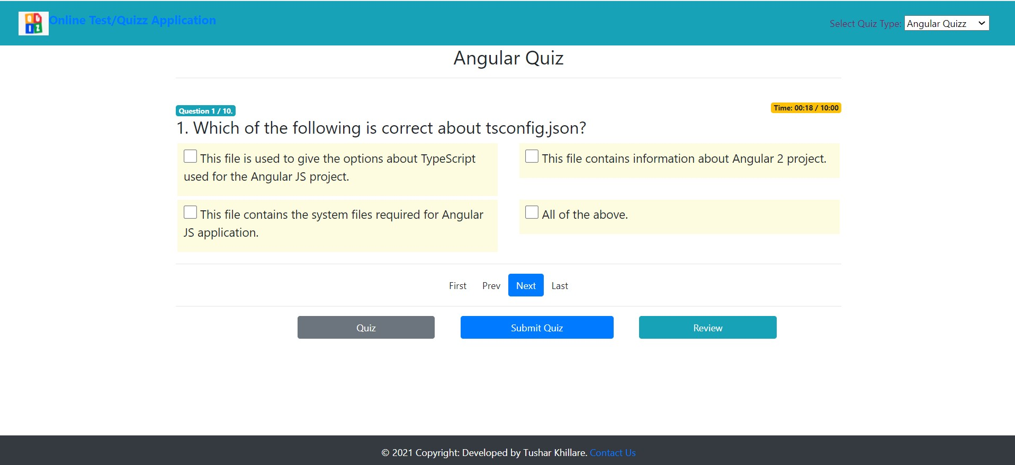

2) JSON Quiz Page.

`

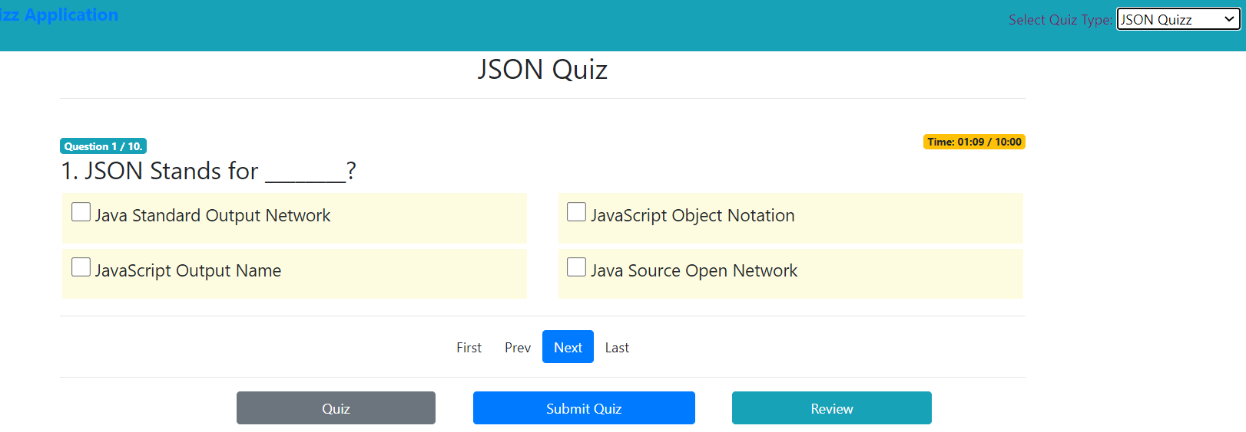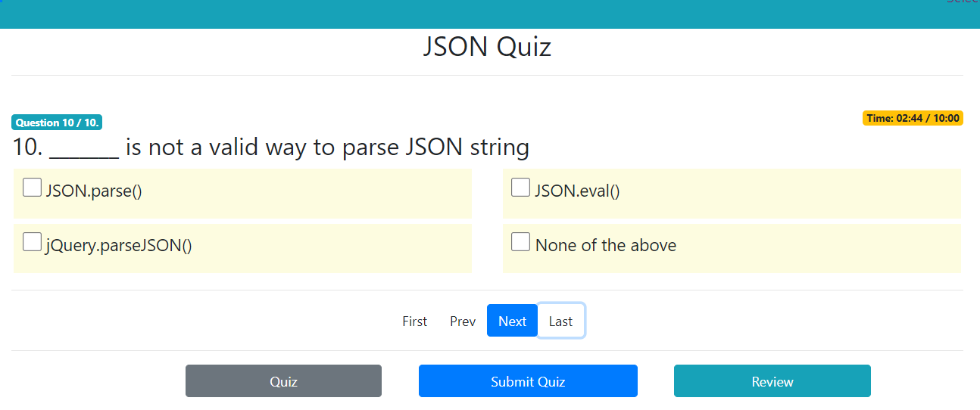

*Next Page:*

* 1. JavaScript Quiz Page.

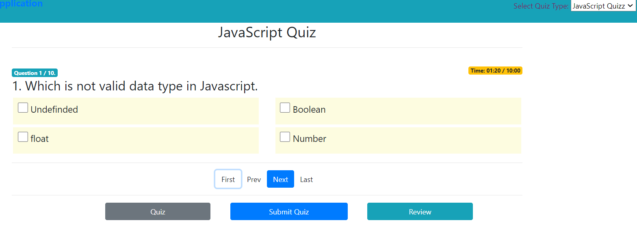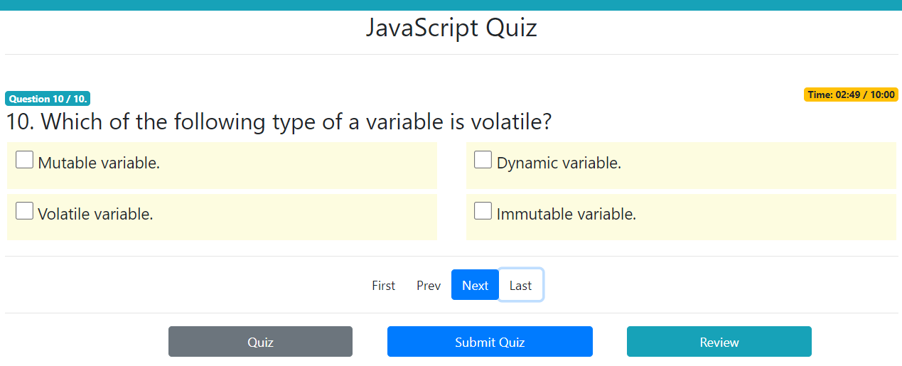

*Next Page:*

* 1. Test Result.

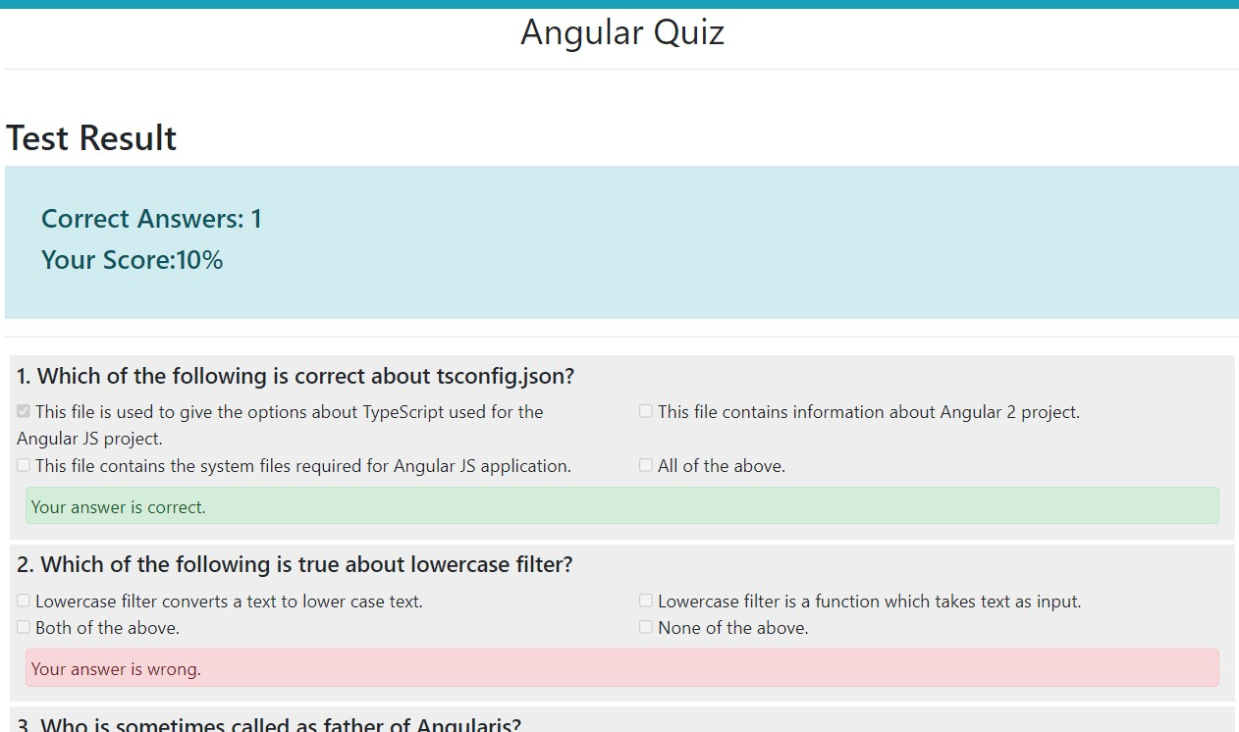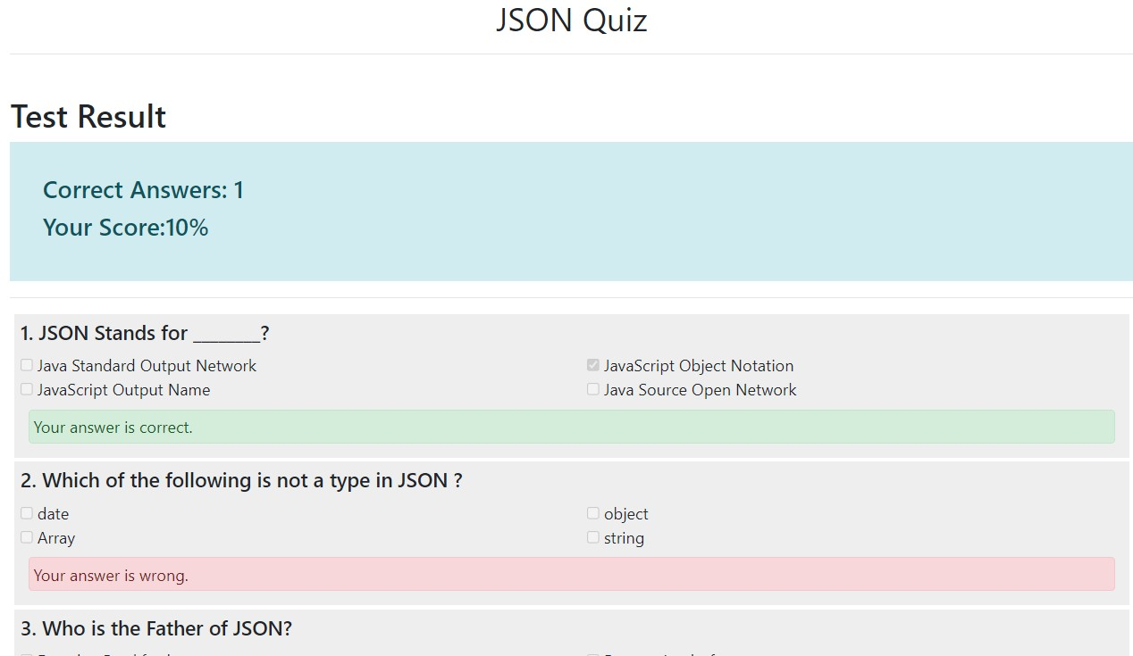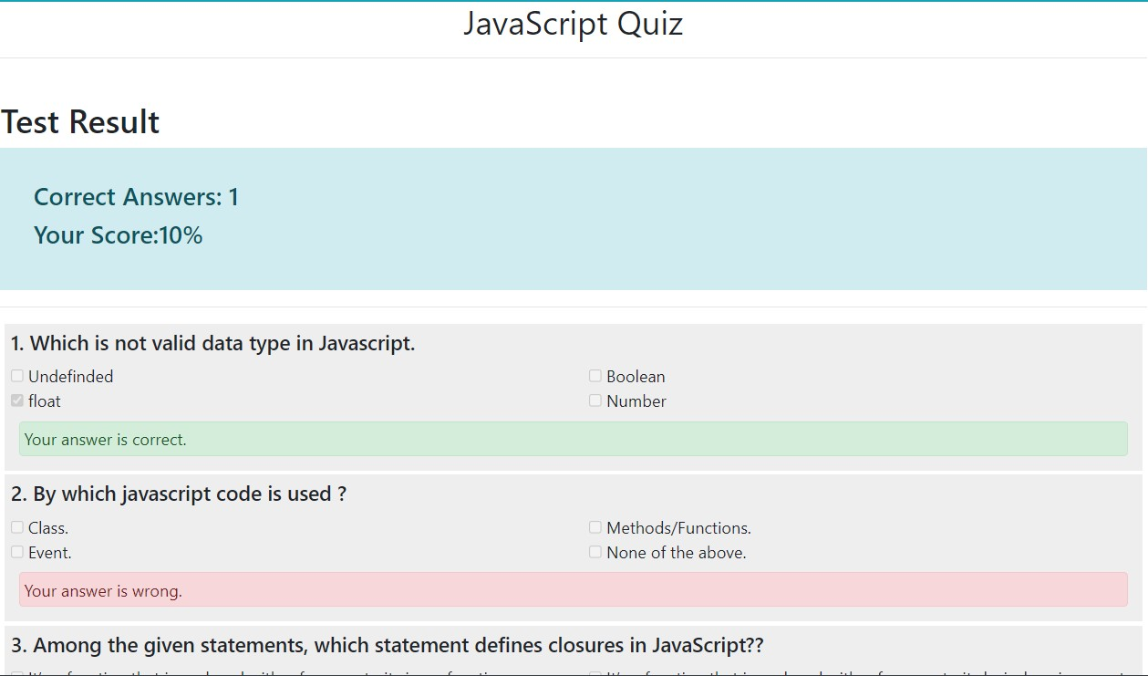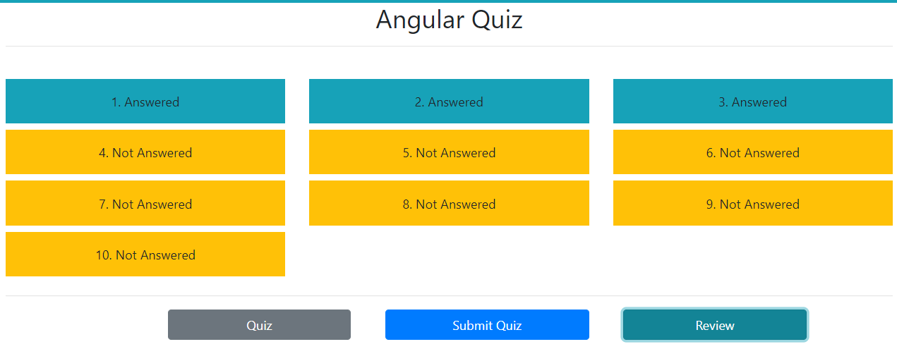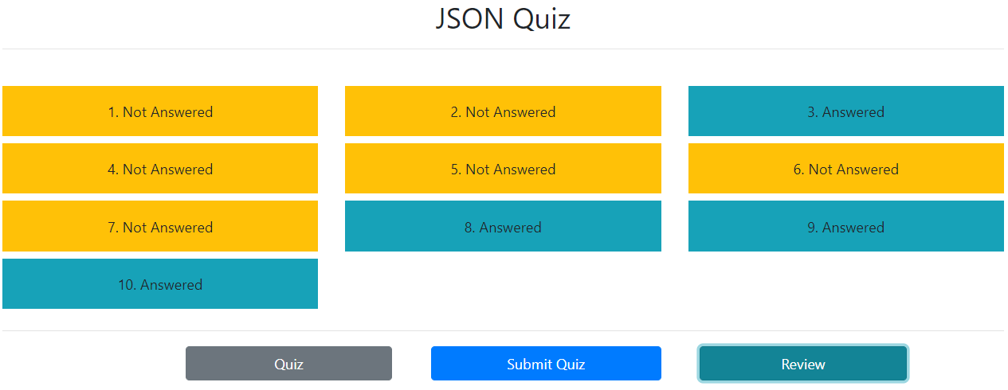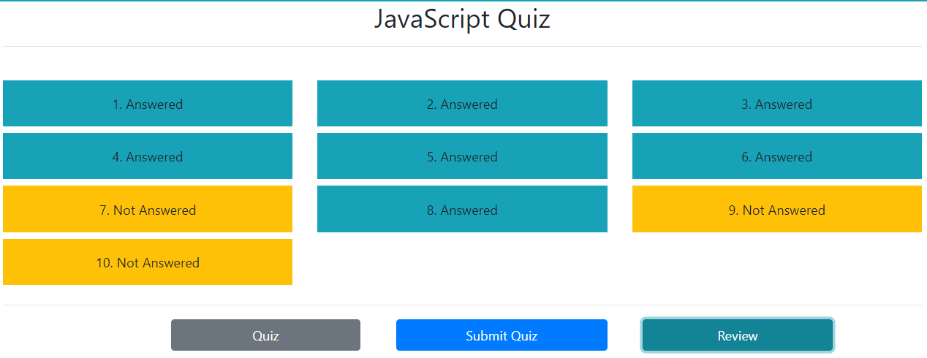

* 1. *Review Pages.*

Thank You…………….